**Codebase Setup for Svatantra/Edelweiss**  
 **PostgreSQL database setup**  
  
Step 1- Download the most recent version of PostgreSQL by clicking on this link.  
<https://www.guru99.com/download-install-postgresql.html> 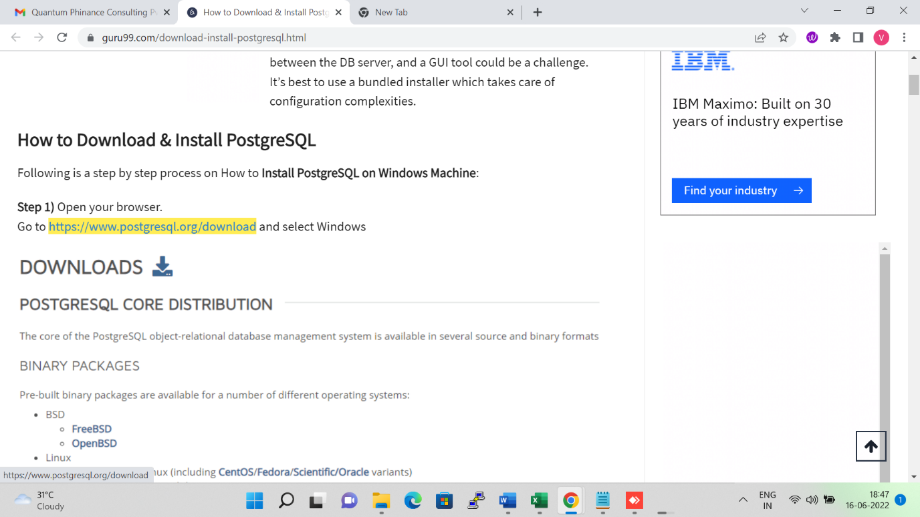  
  
  
  
Step 1- Right-click on the PostgreSQL setup and run it as administrator.  
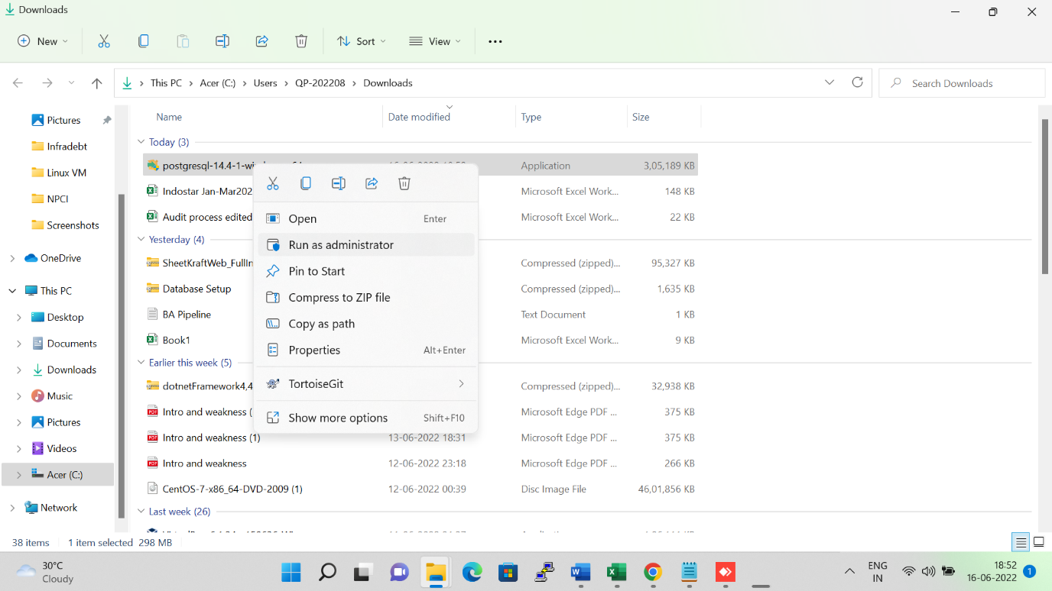

Step 1- Click on the next button  
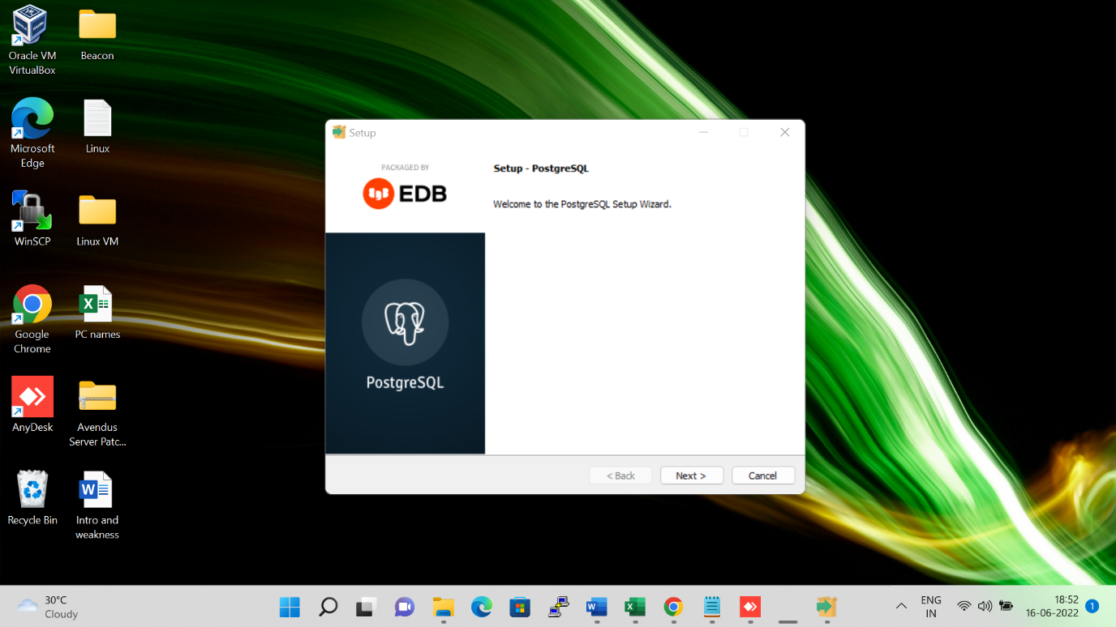  
  
  
Step 1- Choose the path to install PostgreSQL, then click the next button.   
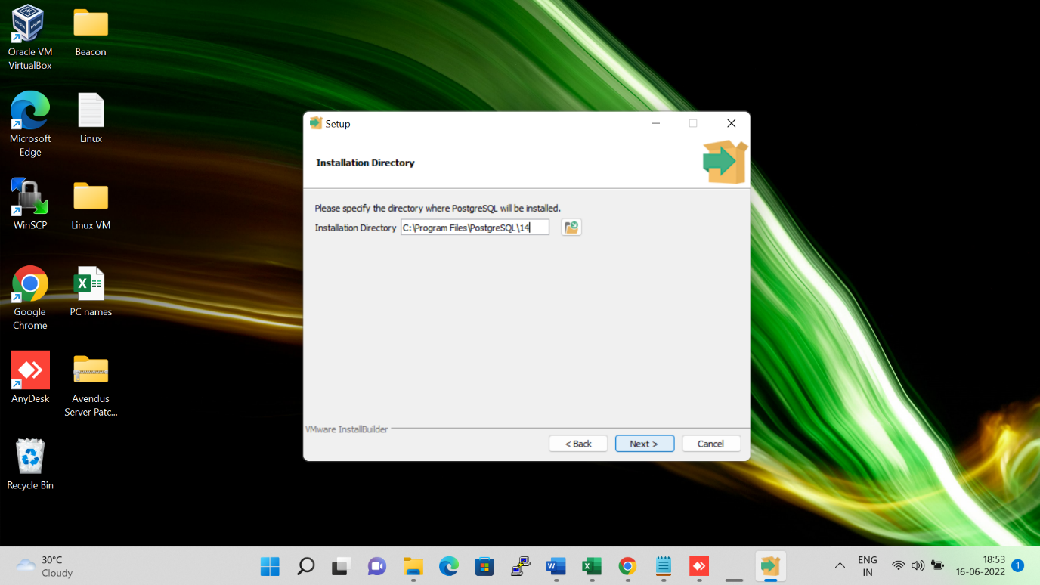

Step 1- Select the components to be installed and click the Next button.  
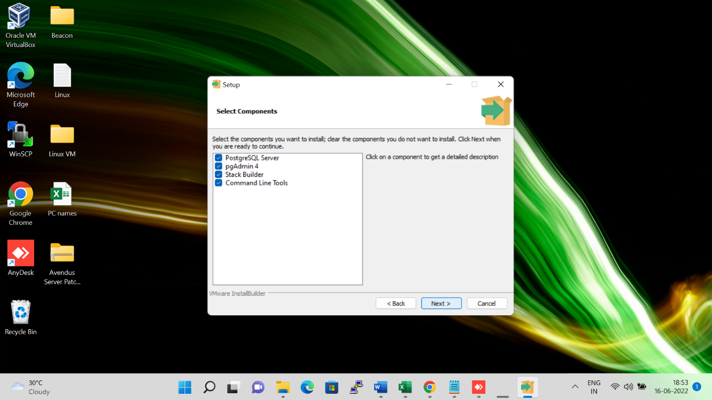  
  
Set password for the superuser of the database, this password will be required when using pgAdmin( PostgreSQL GUI).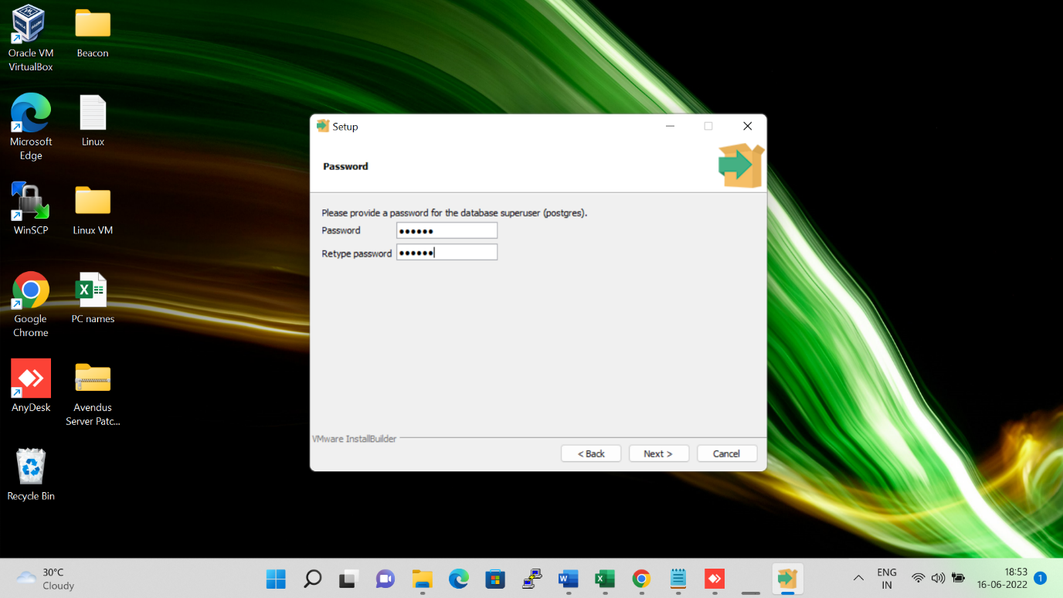

Allow it to be installed on the default port, then click next.  
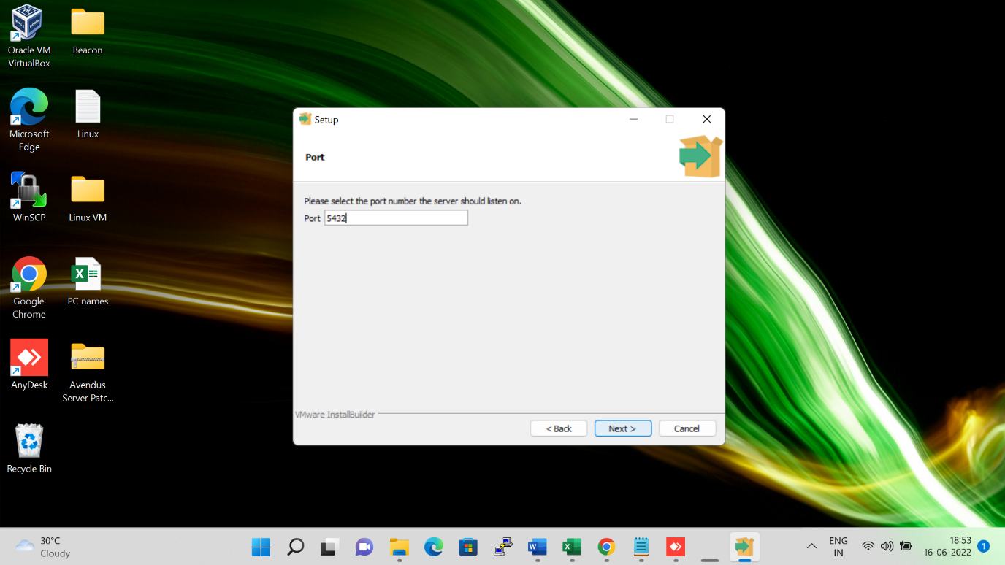

Click on next to begin installation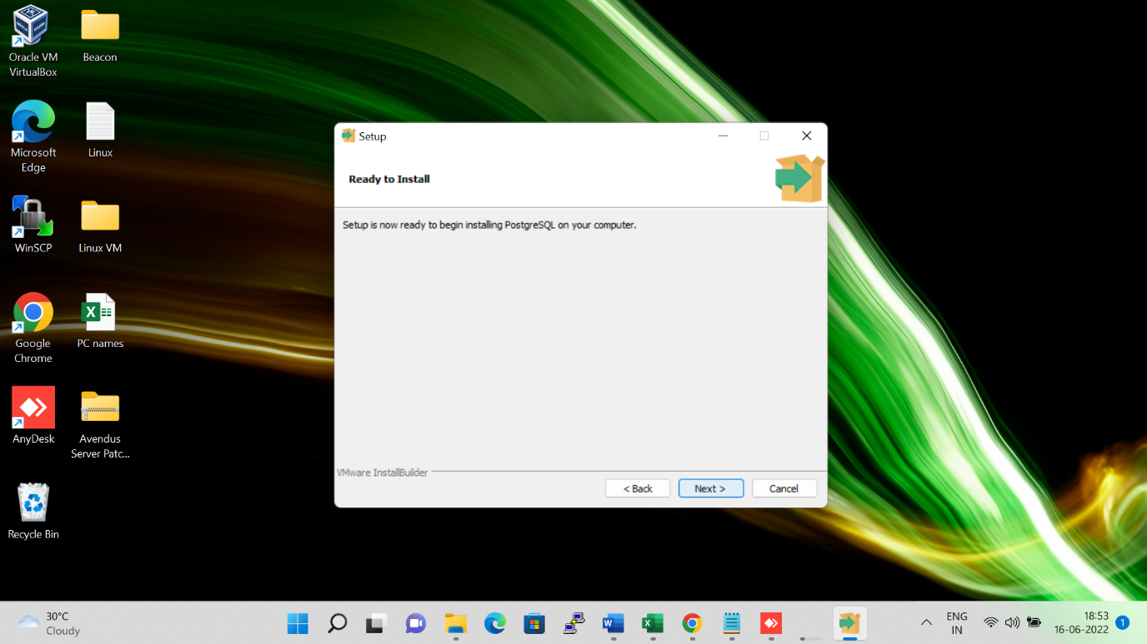  
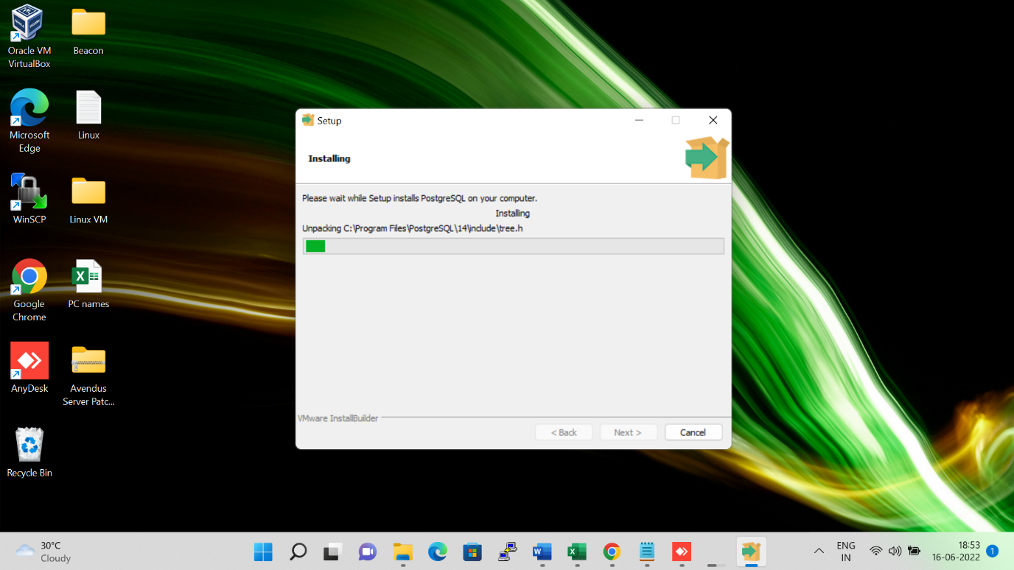  
  
  
  
Click on finish to complete the installation  
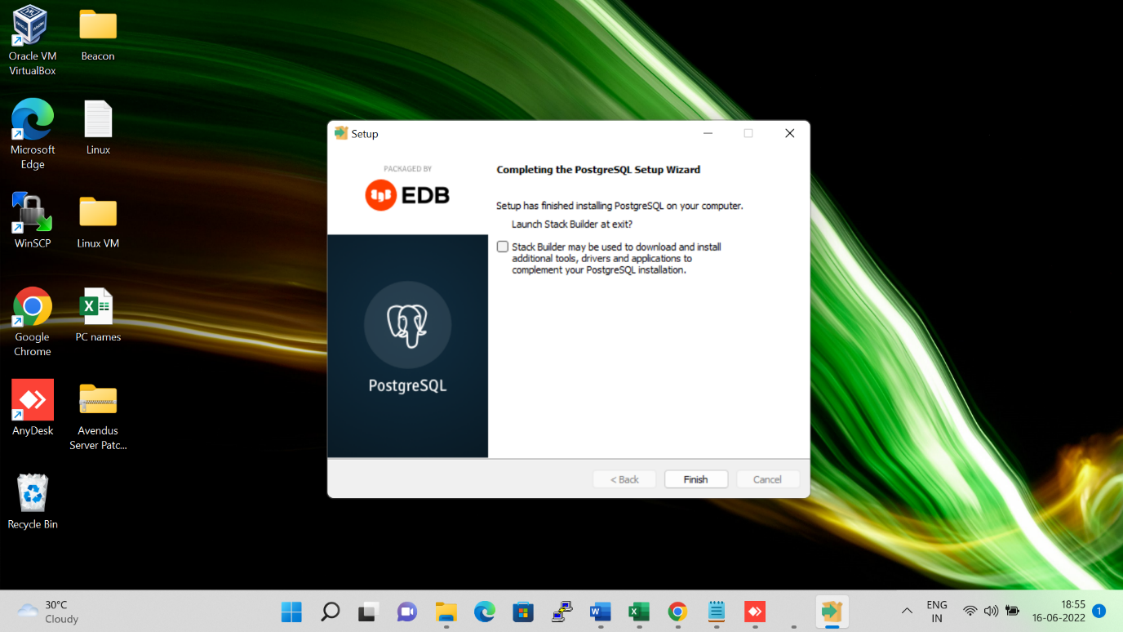  
  
Click on the start menu and search for pgAdmin and open it.  
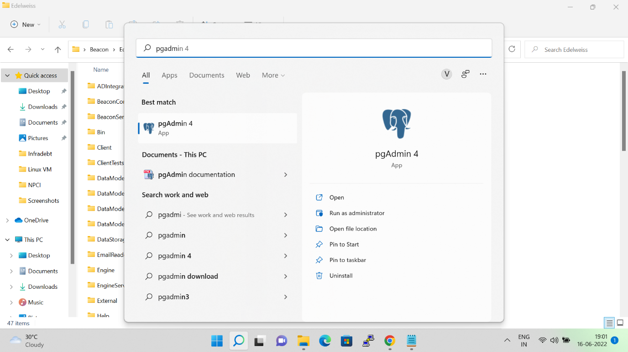

Enter the password you provided at the beginning of the installation and click on OK  
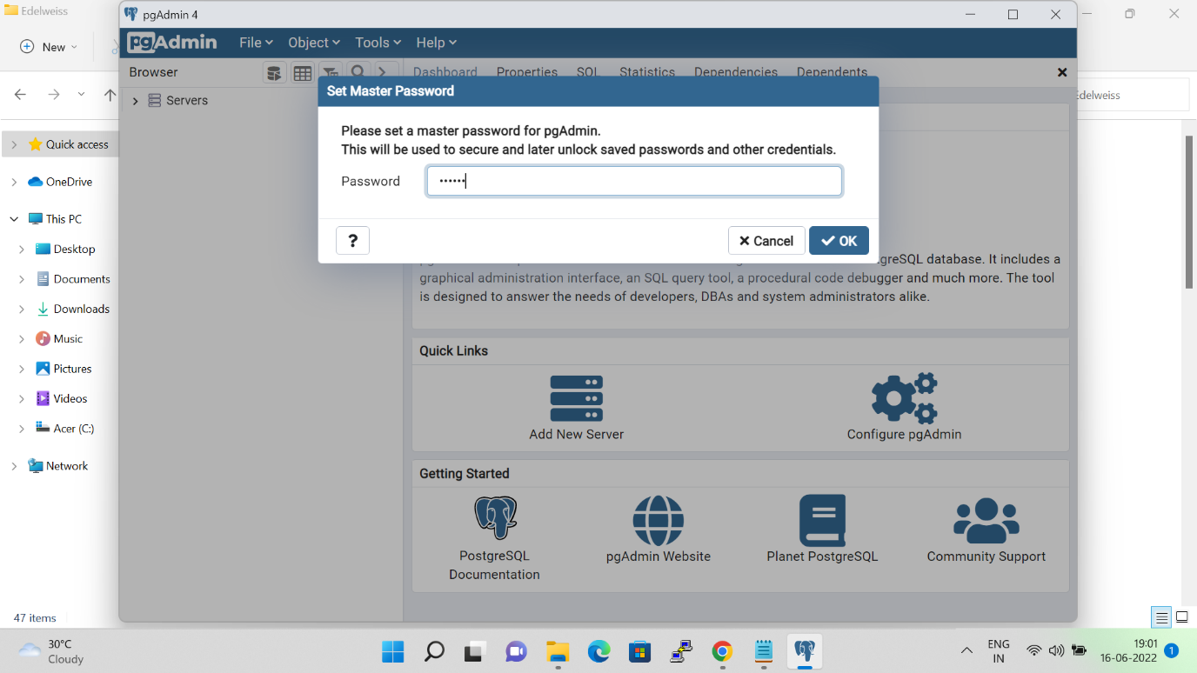

Now you need to expand the "servers" to go to the database, then it will ask again for the password so provide the password once again.  
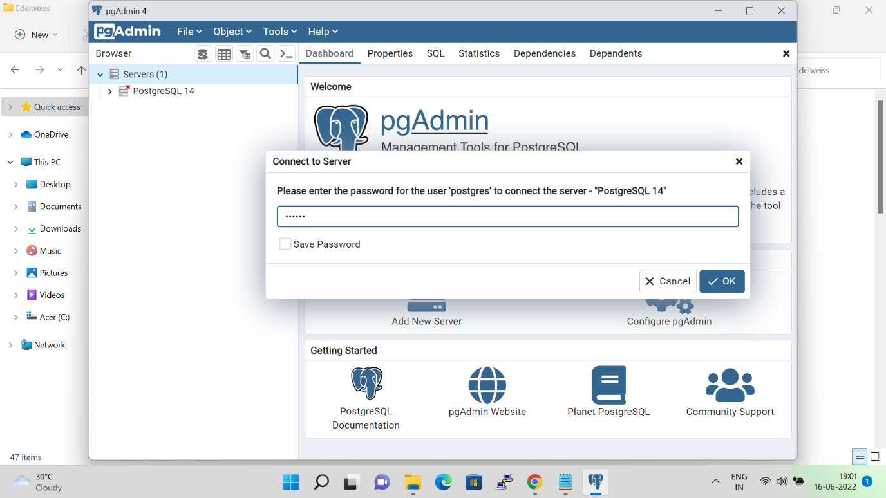

First Expand PostgreSQL 14 and then expand Databases  
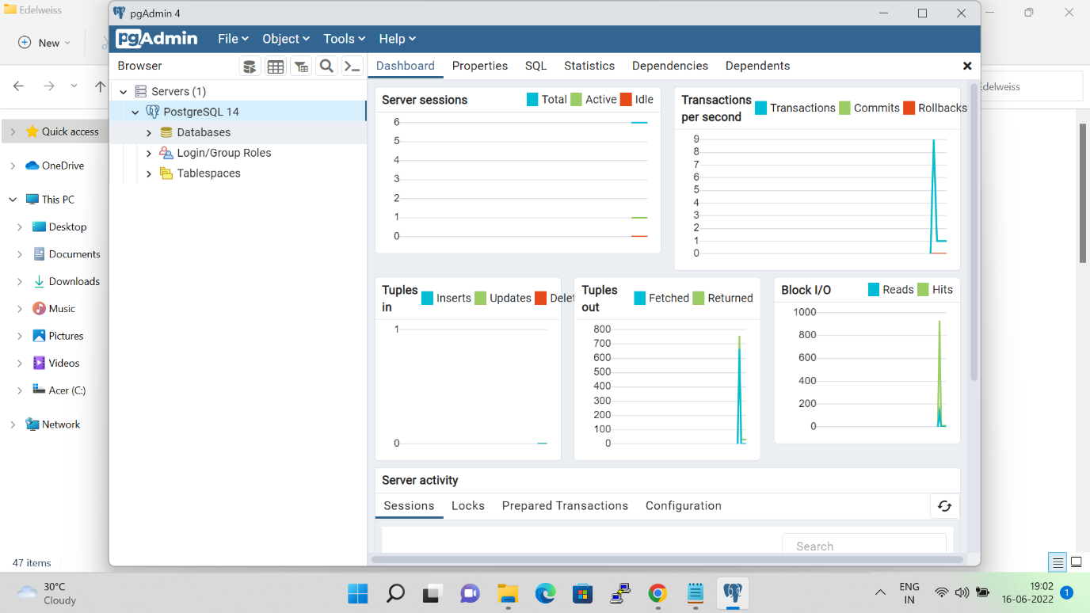

  Right-click postgres and then select the Query tool.  
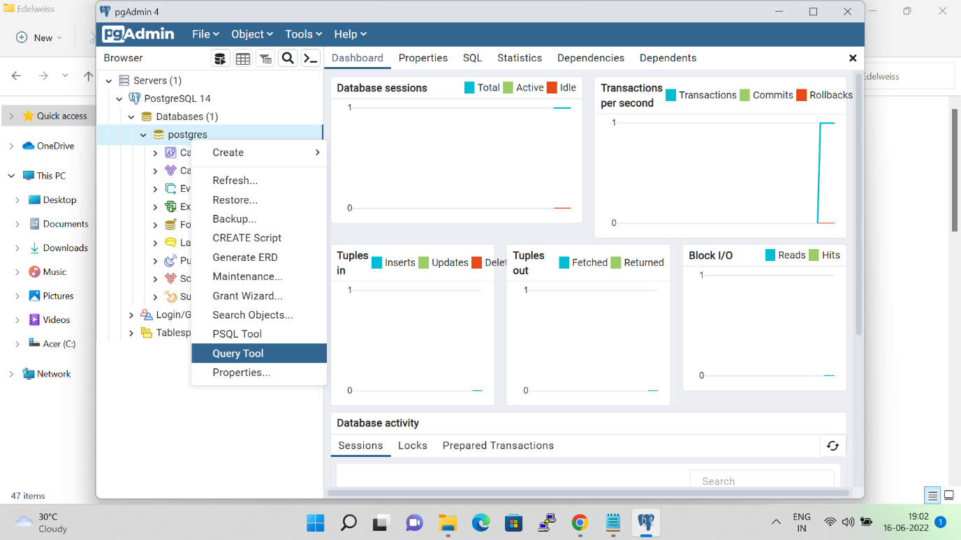

Paste the given query in the query box, then press F5 to execute it or click on the execution button. (In this query we are creating a user beacon with password 123456)   
do $$begin  
if not exists(SELECT 1 FROM pg_roles WHERE rolname='beacon') then  
create user beacon with password '123456';  
end if;  
end $$;  
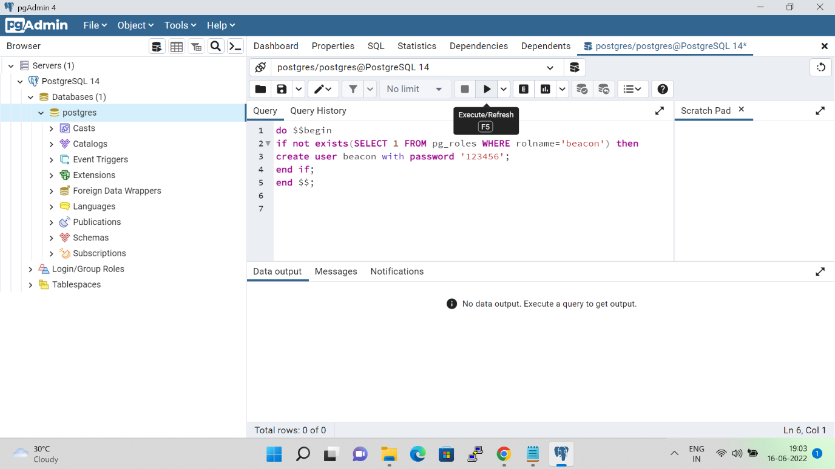

Paste the given query in the query box, then press F5 to execute it or click on the execution button.(In this query we are creating database ‘edelweiss’ with beacon as its owner)  
CREATE DATABASE edelweiss  
 WITH   
 OWNER = beacon  
 ENCODING = 'UTF8'  
 CONNECTION LIMIT = -1;  
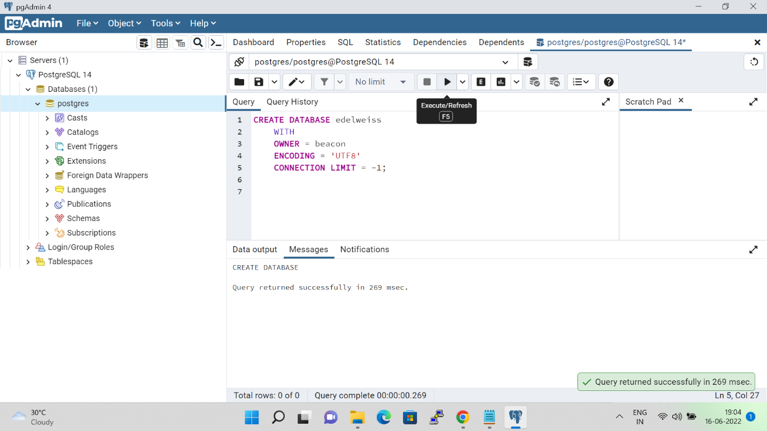  
  
After executing the above two queries successfully, right-click the server and refresh it.  
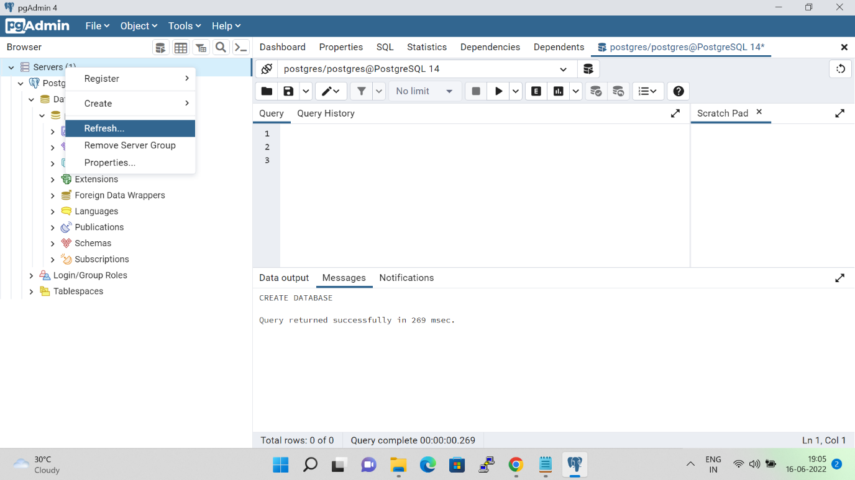Now expand the databases and Switch to Edelweiss/Svatantra database and open the query tool again.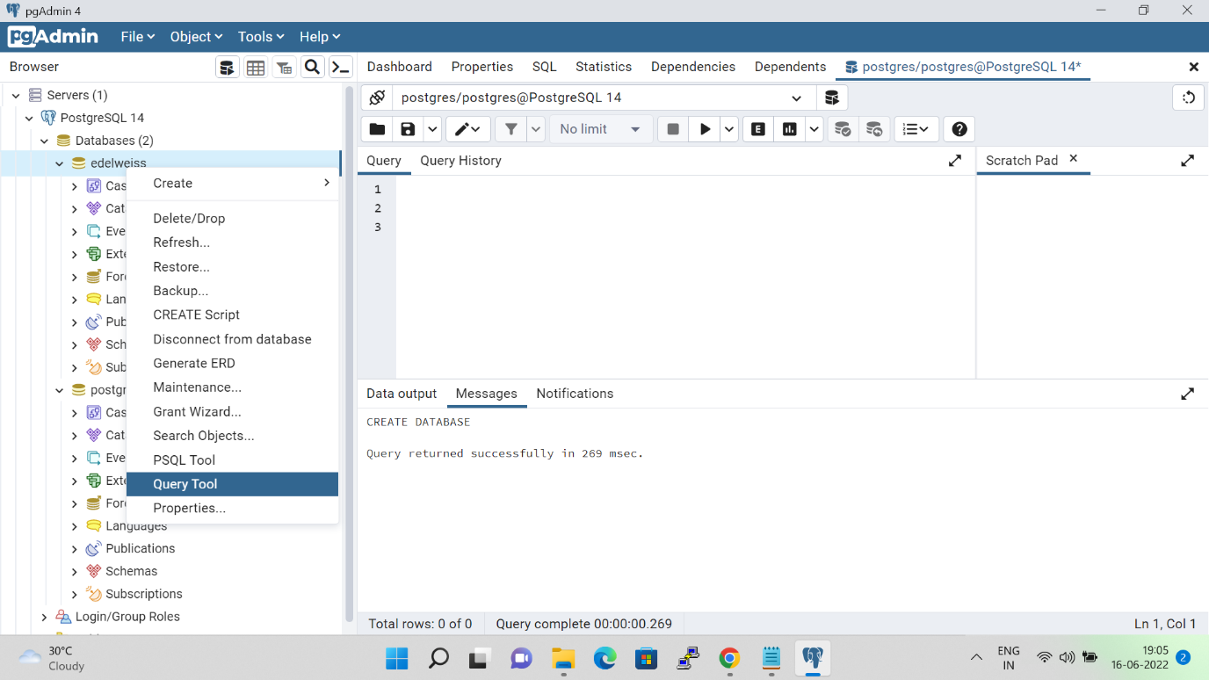

Paste the given query in the query box, then press F5 to execute it or click on the execution button.  
create extension if not exists "uuid-ossp";  
create extension if not exists citext;  
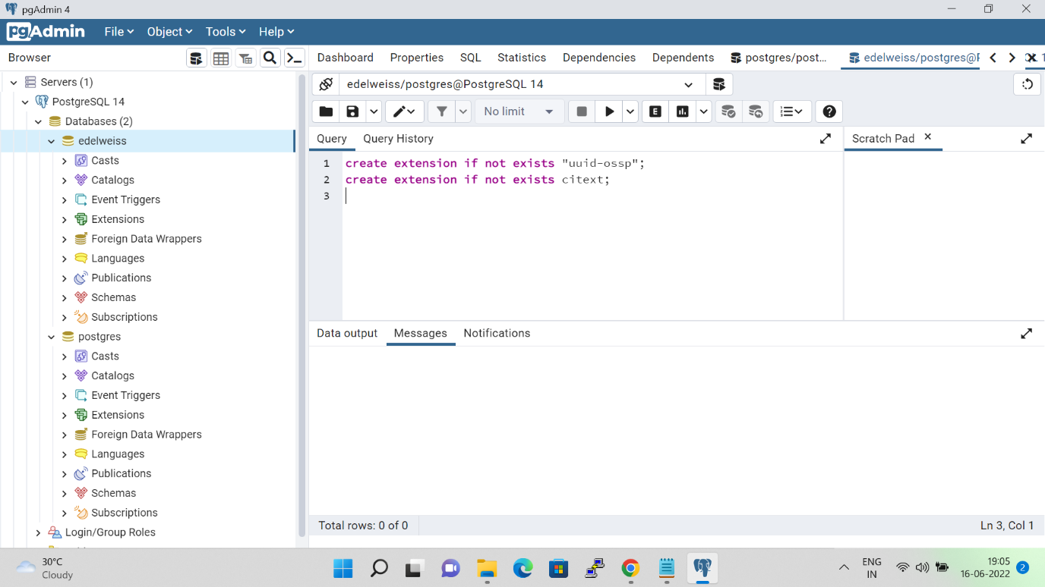  
  
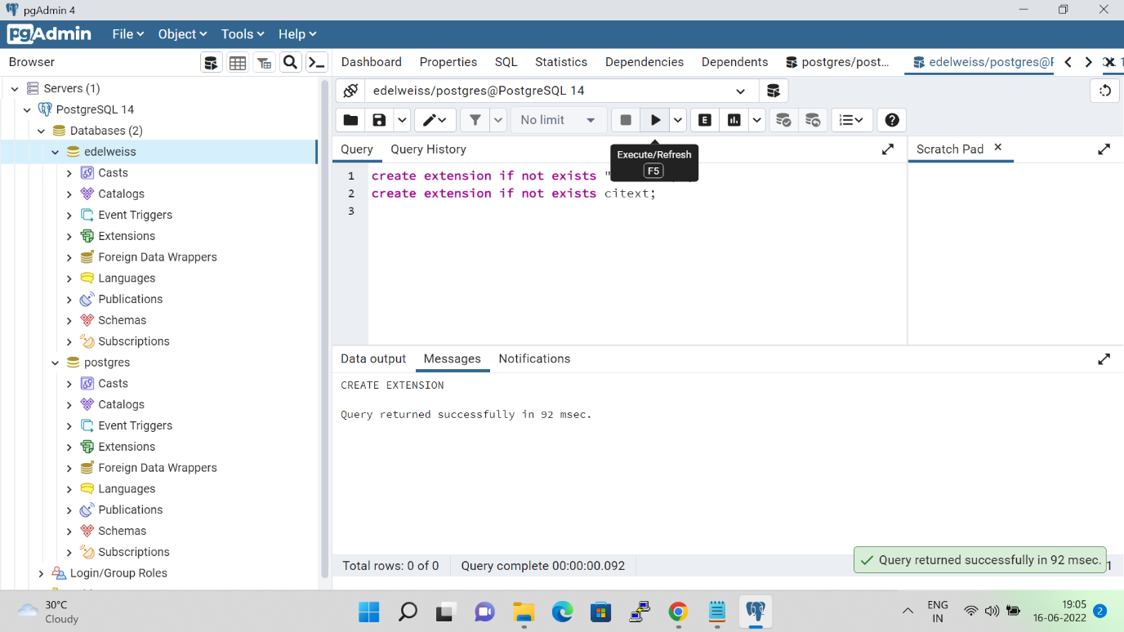

Now go to your codebase folder, Right click into it and select **Git Sync**

Click on **Remote Update**Click on **Show log**  
Select the respective Live/UAT branch and right click on it and select **Switch/checkout to this  
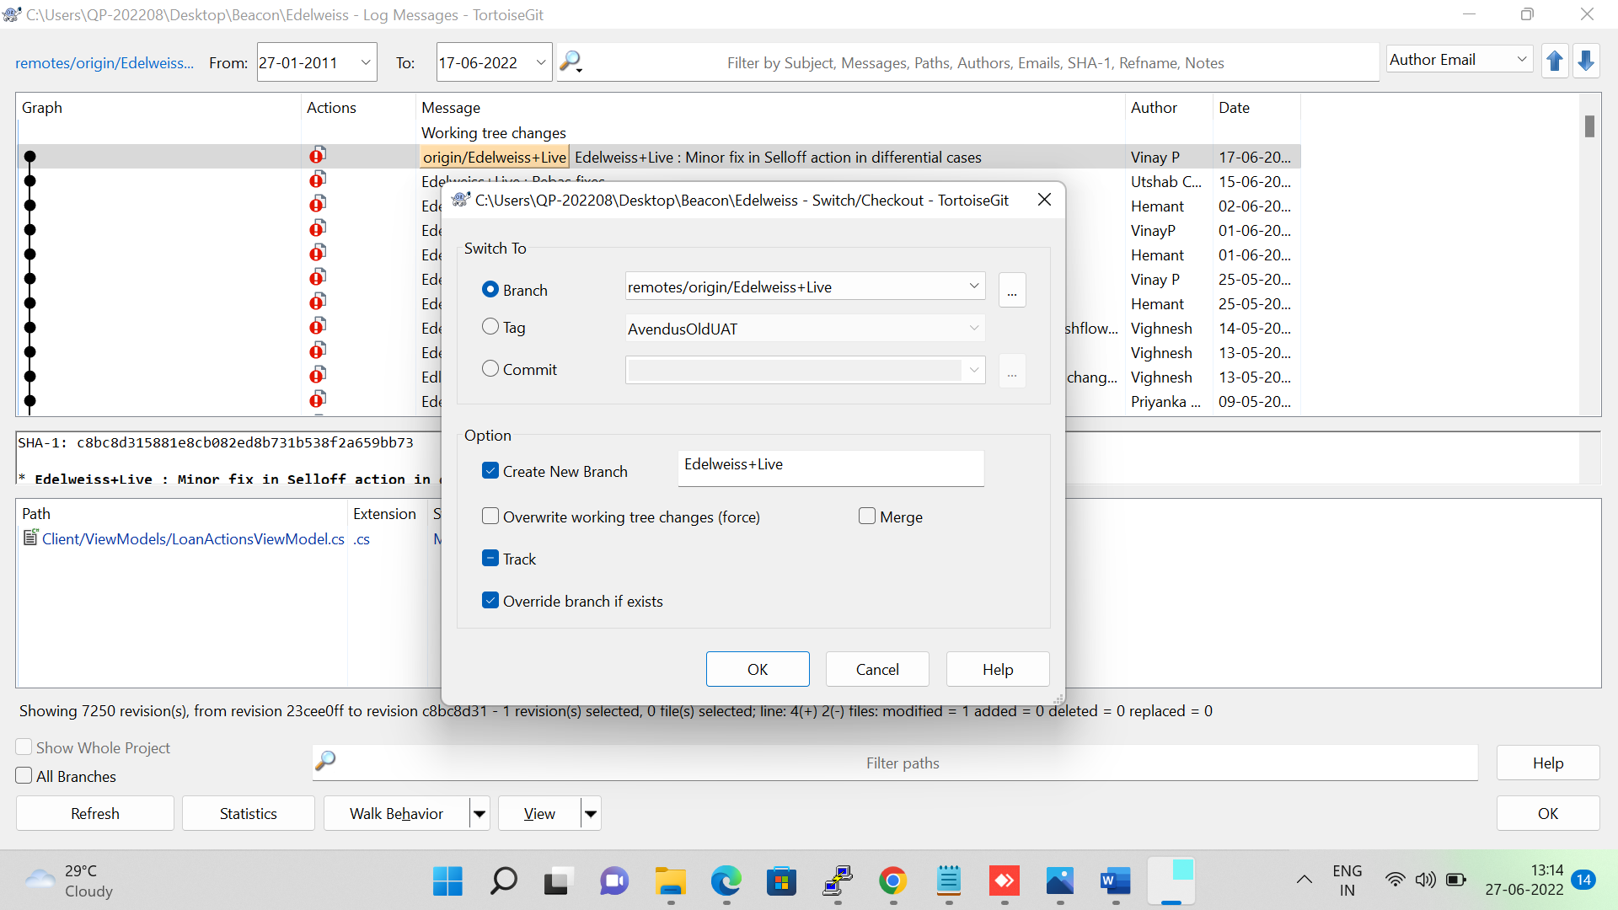**

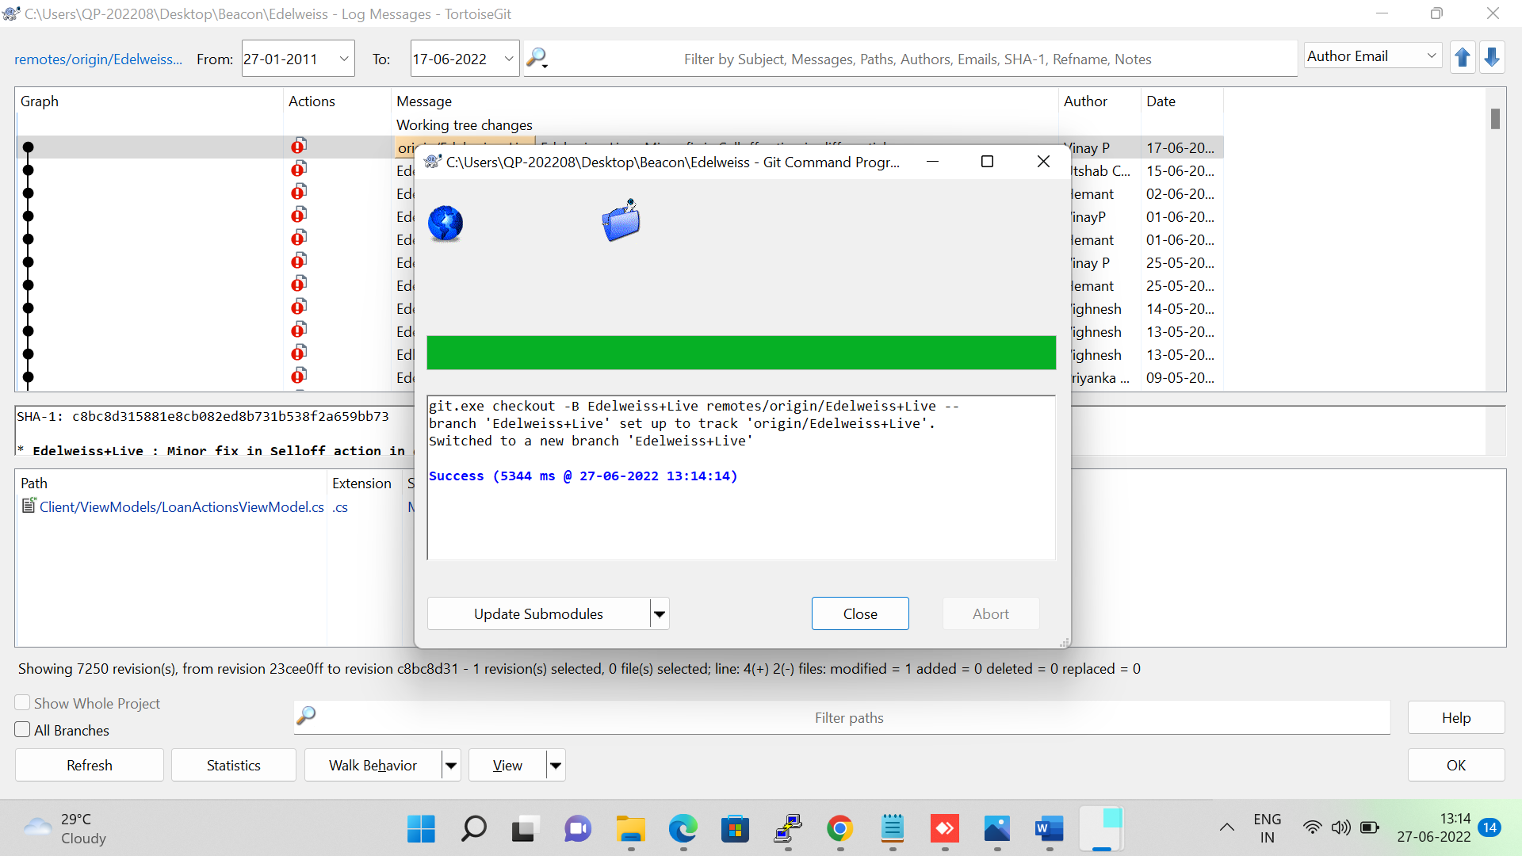

Now download the zip file from the link, unblock it and then extract its file(Sheetkraft Web & Database Setup) to your codebase folder.  
<https://drive.google.com/drive/folders/1UhclaXvlyP7QbWPQYUsIxegyekUk9XIE>

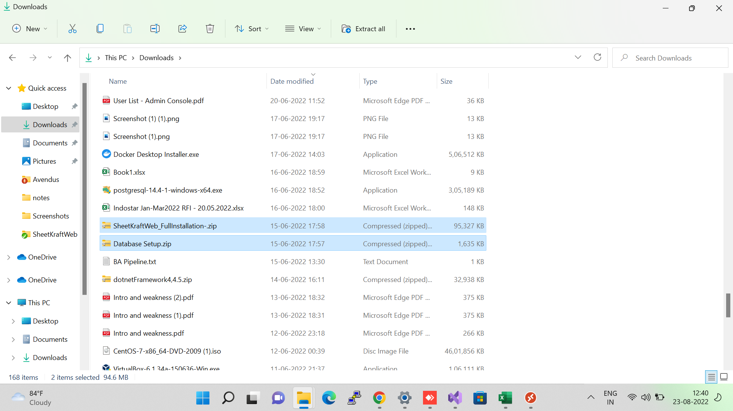

Right-click on SheetKraftWeb.zip and select properties to unblock it  
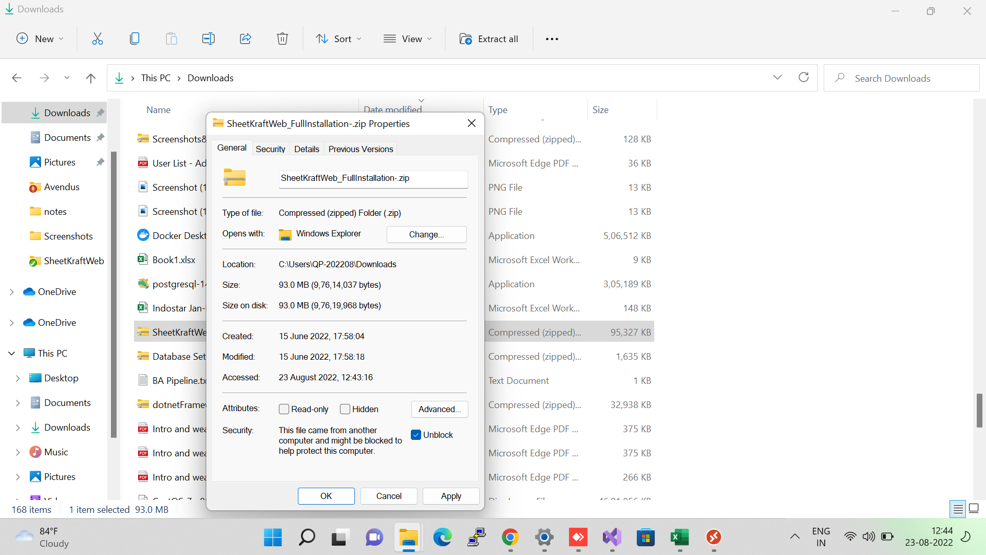  
Right-click on Database Setup.zip and select properties to unblock it

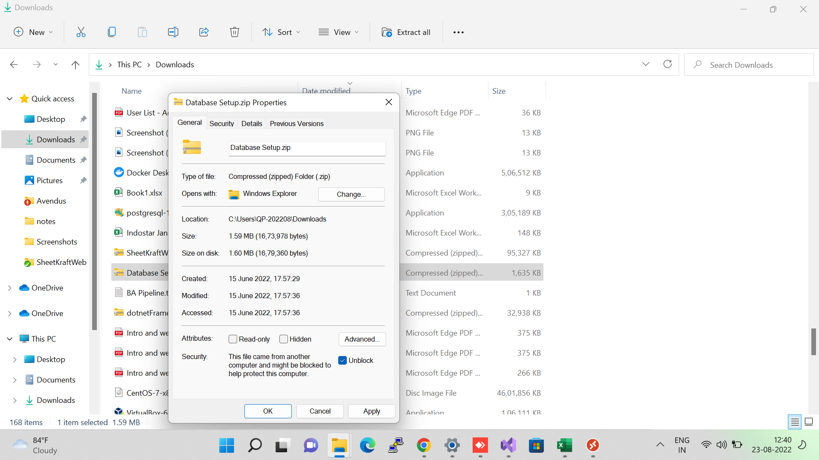  
  
Extract SheetKraftWeb.zip and Database Setup.zip into the codebase folder after unblocking them  
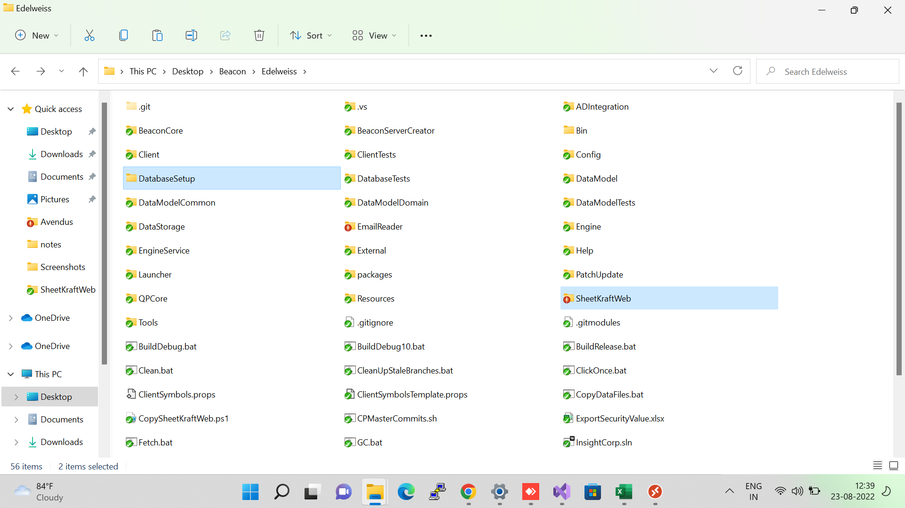

Copy the following string and put it in connectionString in connection.config file located in (SheetKraftWeb > Runner  AND  SheetKraftWeb > bin)

Host=localhost;Password=123456;Username=beacon;Database=svatantramicrofin  
  
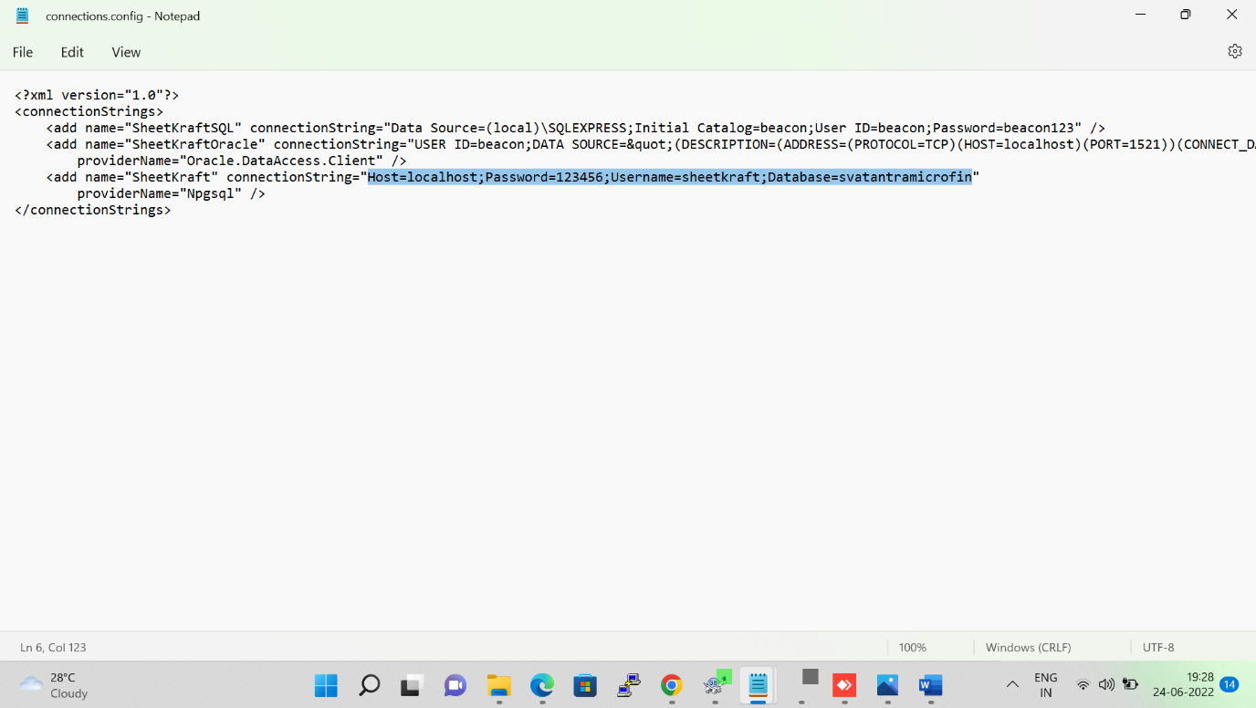  
  
  
Now open InsightCorp.sln  
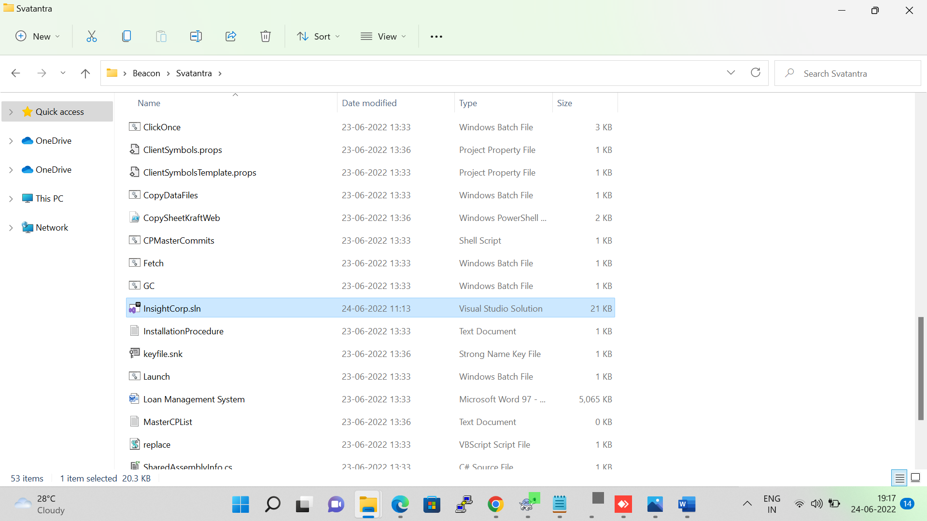  
Go to the solution explorer and Unload BeaconTests, CommonTests and DataModelTests

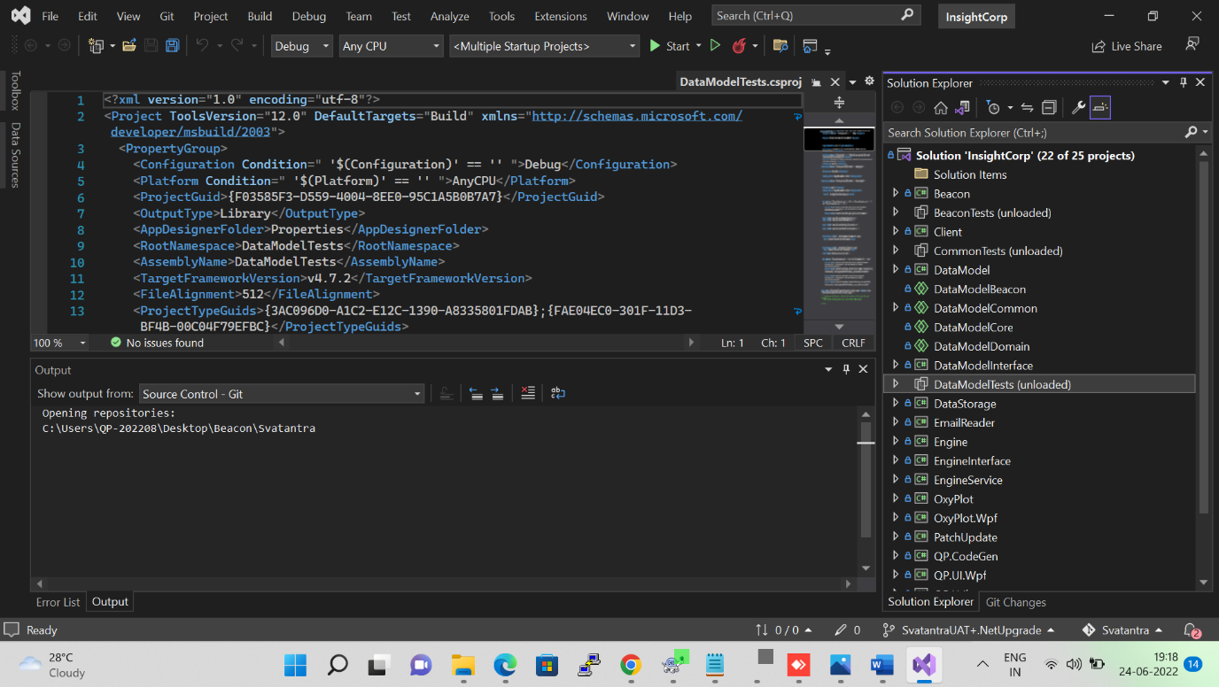  
  
  
  
Right click on **Solution InsightCorp** as shown in fig below and select **Set Startup Projects**  
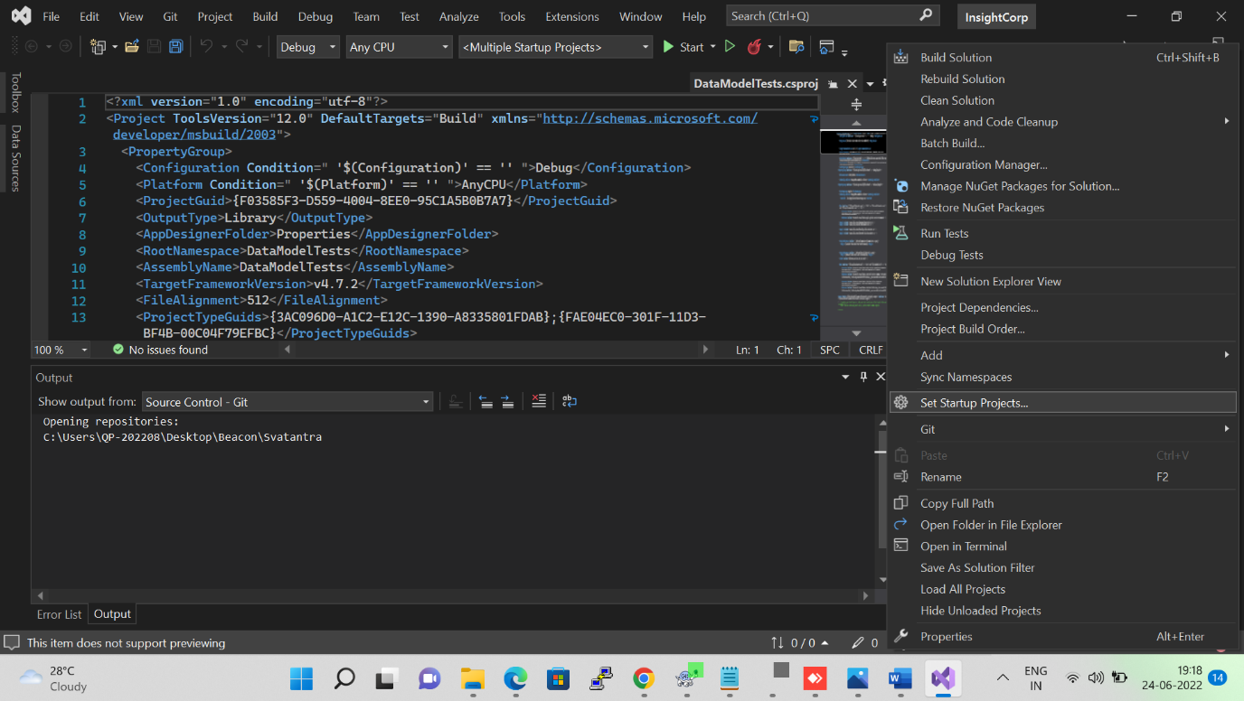

Click on radio button **Multiple setup projects** and start **Client** and **Engine**  
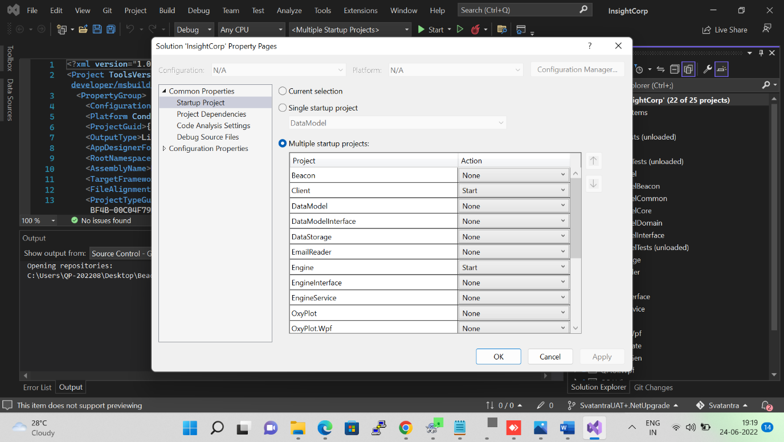

To build code need to Select **Build solution** from **Build** tab  
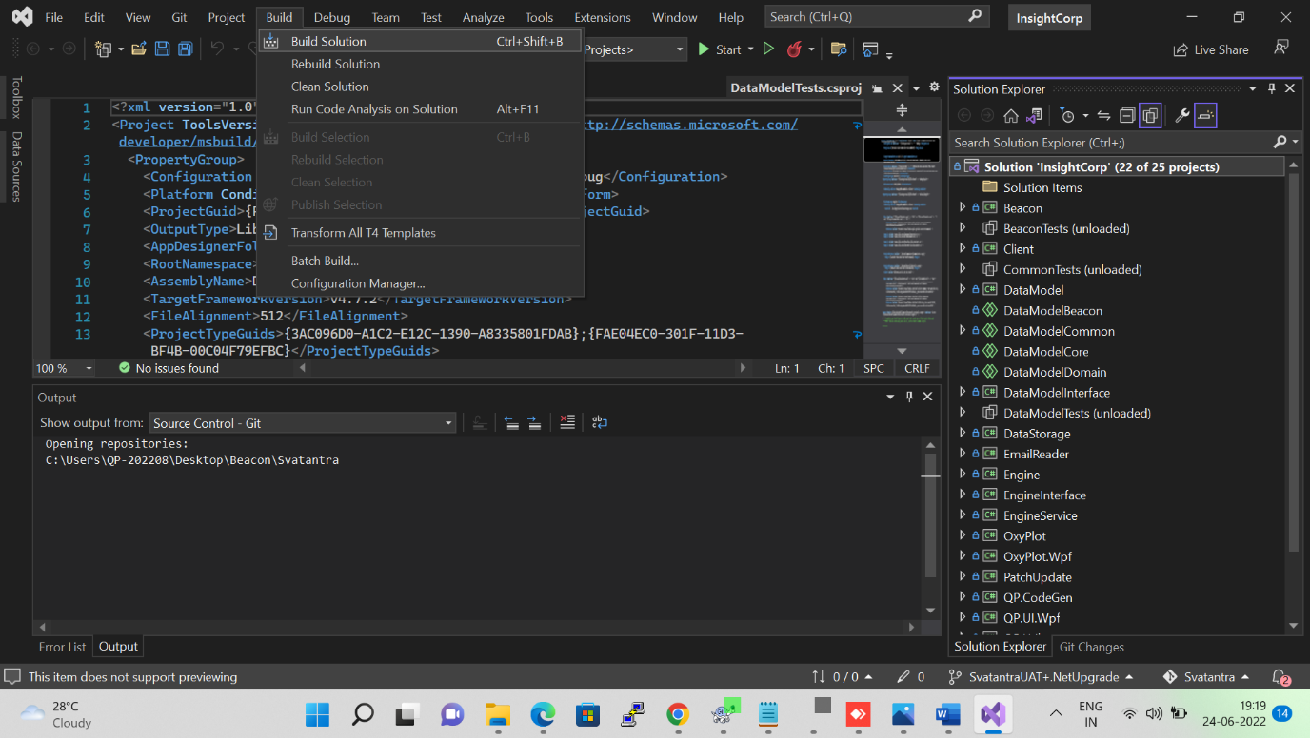  
  
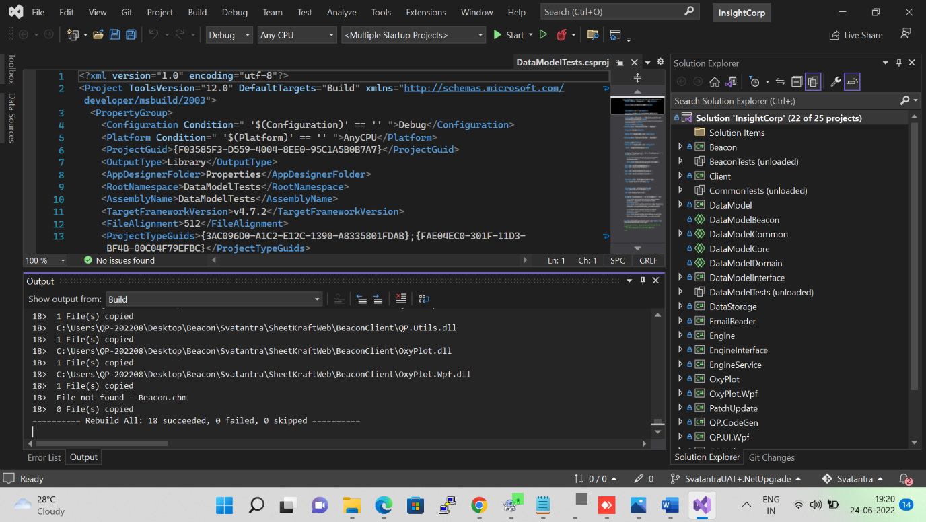

Run Engine to initialize the creation of the table in our database, then close it once it has been successfully run (It is only necessary to do this when creating the new database in SQL. From now on, you just need to use tools to replace the table)  
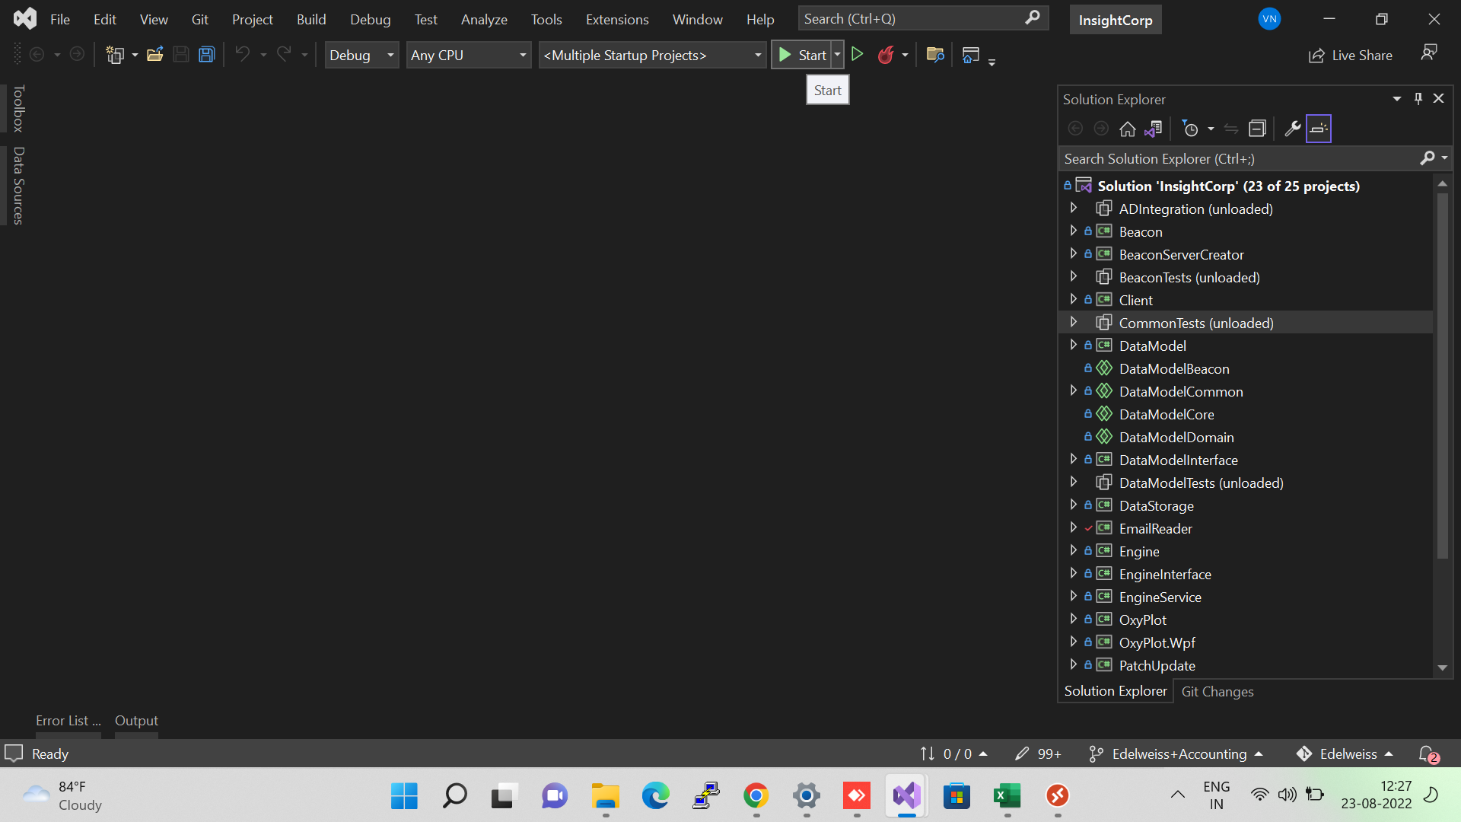  
  
  
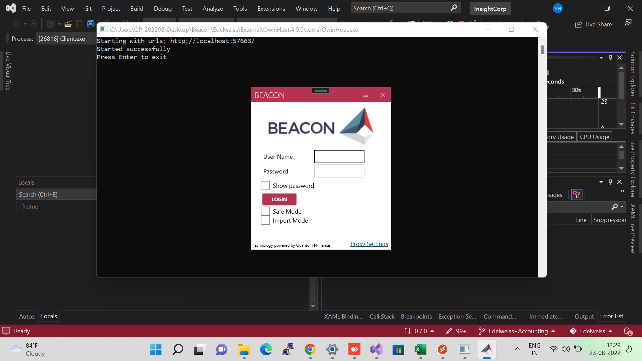

**Replace Database/Upload Database** Go to SheetkraftWeb>>Bin>>Tools.exe (Right click on Tools.exe and Run as administrator)   
Select **Database Dump** and then click on (three horizontal dots)  and load Dump

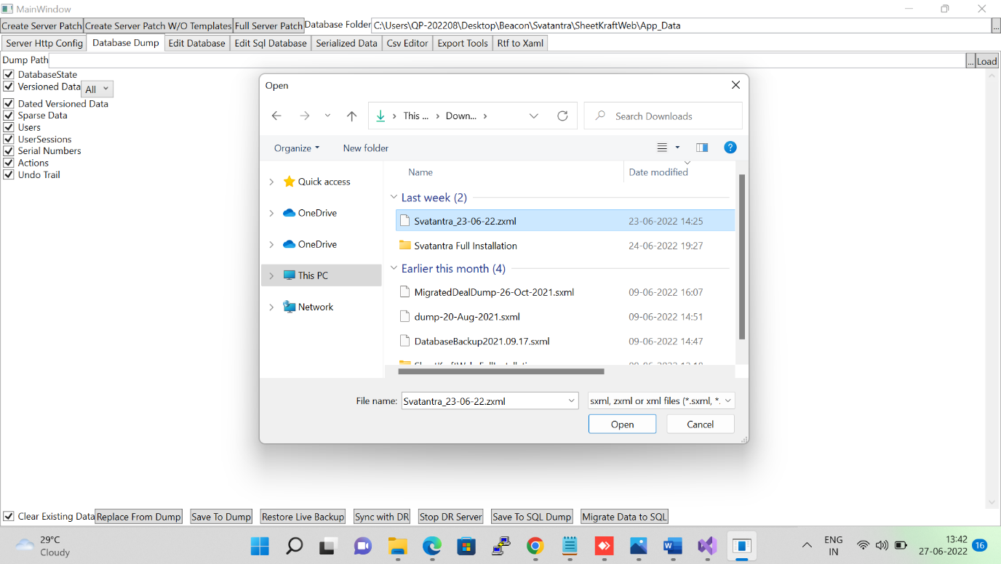  
After successful load dump it will pop up Dump Loaded  
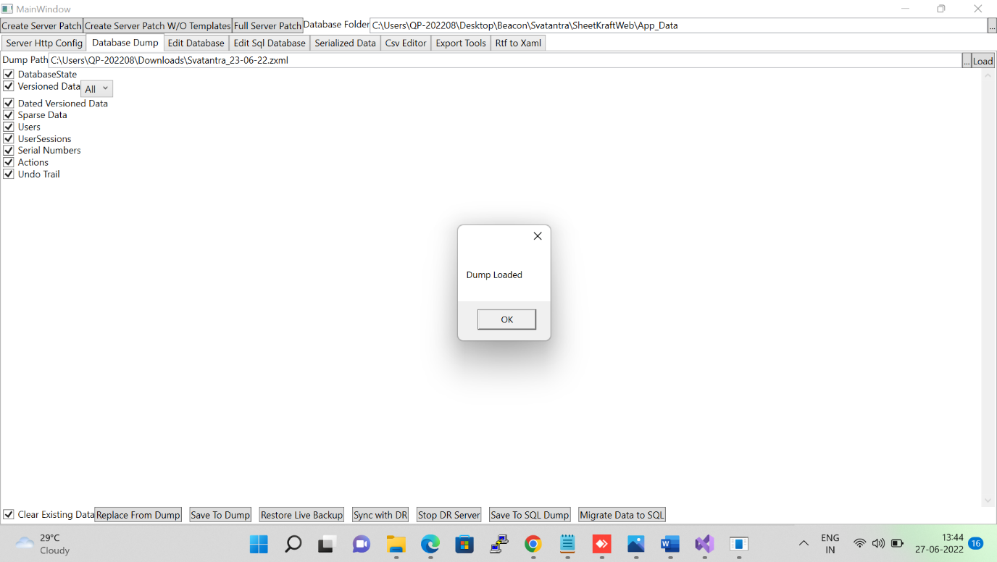  
  
  
  
  
  
  
And then, click on **Migrate Data to SQL** to upload latest loaded dump.  
